2025 APPLICATION PROCESS

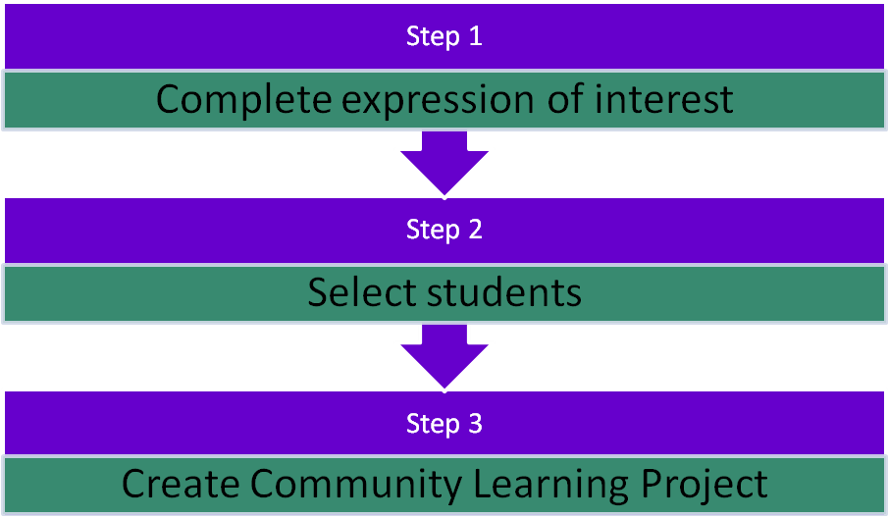

Step 1
Complete expression of interest
- Cross-check the regional allocation matrix (http://www.snowyriver.vic.edu.au/applications/ssl-regional-allocation ) and make sure your region is allocated to the term of your choice and to the campus of your choice.
- Find the liaison teacher(s) at your school. It can be more than one and often is better if this is so. They are going to be the lynch-pin and the key to the team’s success and the individual student’s preparation, separation and reintegration for the program. The role description for the liaison teacher can be found in the Guide to the Liaison Teacher on our website (http://www.snowyriver.vic.edu.au/applications/the-home-school-liaison ). There should be a time allocation to this role if the school is to have a successful overall experience in this program.
- Complete an Expression of Interest form on the next page and send it to the Snowy River Campus alpine.school.snowy.river@education.vic.gov.au by the end of Term 2 2024.
(Please only send Page 3 & 4) This will apply for all 2025 programs at all campuses.
- The Liaison Teacher, Principal and School Council President need to sign the Expression of Interest form. This should be completed by the council meeting in May/June.

Step 2
Select students
- You will be advised of your success in gaining a place in 2025 in term 3, 2024.
- If selected in the expression phase, Schools will then be advised after the selection process on the number of student positions available for each school and the gender makeup required.
- In expressing interest in the program, the school accepts responsibility for selecting a team of students whom it deems will benefit most from the leadership experience. Careful consideration must be given to student selection and as such liaison teachers and/or Principals are encouraged to participate in a Webex meeting with SSL staff. You will be advised of this meeting at least 2 terms in advance of your school’s participation. On acceptance, this process should begin. Please note you may not get the full allocation of students you have requested. The best practice would be to select 4 students with 2 emergencies.
- The process of selection of a team and the development of a project can happen concurrently, and often this can work very well. Some schools use the process of development of projects to indicate a commitment to the team and hence student selection.
Step 3
Create Community Learning Project
- A Community Learning Project (CLP) has to be identified. See exemplars of projects at the end of this document http://www.snowyriver.vic.edu.au/clps/clp-overview . You will be asked to detail successful CLPs from past participation. The school will and should approach the SSL campus for advice and support in developing the CLP.
- Home schools then need to support the team in developing their project. See exemplars again.
- The CLP proposal must be submitted with all the other documentation (student confidential/medical information, consent form, ICT user agreement and recording permission form) in week three of the term prior to attending.

Expression of Interest for Program
School name and Campus of choice:
_______________________________________ SC/P-12/HS/other of ________________Region would like to express interest in the program at Snowy/Alpine/Gnurad-Gundidj/Don Valley Campus (circle one or more) in term(s) ____ and/or______2025 (refer to website to ensure allocation to site and term).
We wish to have _____ team(s) of ______ students made-up of ___________boys and _________girls.
School for Student Leadership reserves the right to offer a different number of places and gender mix. Gender equity is essential due to the accommodation arrangements at all campuses. Every attempt will be made to accommodate single sex school teams and balance the overall gender ratio of the campus.
Koori Student Inclusion:
The SSL cannot fund Koorie students, but will privilege places. Funding for this is now included in Equity Funding in your school SRP. We can include _______boys & _____girls who identify as Koorie (insert number and gender, this assists our allocation priorities and advocacy abilities).
Financial Consideration & staff support:
__________________________________(insert school name) acknowledges it is liable for $900 per student in the term of the program, payable on invoice by the end of the term of the program. Shorter programs will be pro-rata. The school acknowledges it will support students financially initially directly through school funds. The school will then provide assistance with seeking sponsorships or in kind support from the community, and will seek or not seek contributions (full, pro-rata or otherwise) from families of participating students as appropriate. We acknowledge the school will be responsible for providing a liaison staff who will work with the selected student s and who will support the team.
Liaison Teacher’s name: ______________________________ Signature: ___________________
We will undertake a student selection process that is inclusive and will elicit the best participants for the program and agree to put students’ needs at the centre of the decision making in the selection process.
This expression of interest and undertaking has been approved at the school council meeting held on ___/___/____.
School Principal (print name):________________________________Signature: _____________________
School Council President (print name): __________________________Signature: ___________________
Background and support information for Liaison Teacher to complete
NB: These criteria are in weighted order. Use only the spaces in the boxes provided
- Has your school had a team attend the SSL program at any of its campuses in the past? If so, what term, year(s).____________________________________________________________
- If you have had a team in the past at any campus, please describe and advise if they completed their Community Learning Project? Please explain circumstances around either success, incompletion or otherwise.

- Please describe how it is intended that participation in this program will contribute to improved student learning and/or changes in teaching and learning practice at your school.

- How is your school going to provide support and commitment to the team and project, especially upon return?

- Please describe how participation in the program links to the schools MY and other student learning intentions in its AIP/Strategic Plan?

- Multiple sources of feedback- If you have had a team in our programs before, you should get the students, parents and teachers who or were involved to provide a reference for the support they received/would have benefitted from upon their return and any advice they would provide to improve the outcomes for the next team? Please attach.
- We have read the two CLP exemplars and understand which process our school will adopt if our expression of interest is successful!
- Liaison Teacher signature ________________________________________

Community Learning Project proposal example 1

Tramline Secondary College, Central Metro Region
Background
We are the team of students who have been chosen to attend the Alpine School Campus for our school. We had to apply to be a part of the team. We went through an application process to select us. First, Ms Schlitz told us about the School for Student Leadership and Alpine School Campus in an assembly. She said our school had been successful in being allocated 6 places, three boys and three girls for term 2 next year. She asked the students who thought they might be interested to meet at lunchtime the next day. There were 27 of us. We had to write a page about who we were and what we thought we would get out of going to the Alpine School. Then we had an interview with a group of people (they called themselves the selection panel). There were two teachers and three year 10 students, who had been to another School for Student Leadership campus at Snowy River before, on the panel.
Once we were chosen to be on the team there were 8 of us, two spares in case someone dropped out at the last minute. It was like going for a job in the real world and that would be a good skill to have. We were really glad to have learnt that sort of thing at school. We thought that you only learnt that real stuff when you left school!
We had four, class-time meetings with Ms Schlitz over three weeks, to decide on a project idea, although the team met two more times at lunch in the library. Some of the boys thought that the project should be about re-grassing the footy ground after the drought. Some of the other team members thought that they should do a project on raising awareness of GLBT kids in our community. Ms Schlitz talked to us about the need for the project, whatever we did, to be really for the wider community not just our school community. It would mean that we would have to work with people outside the school as well, and that other people outside the school would benefit, Most of us liked that, as some of us had part-time jobs and really liked the sort of things that are like in the real world.
We video-conferenced the teachers and students at the Alpine School Campus to ask for their help. Mr. North up at Alpine was really good. He said that some of the projects are too big and really hard to complete; keep it simple. He suggested we have a look at some of the examples on the website.
We talked about the things that effected young people in our community. One of the girls told the group about when her thirteenth birthday was gate crashed, and that really started us on the idea we decided on.
We ran a survey with the rest of the year 8s and 9s, and heaps of the students agreed on the big problem of gatecrashers. Because of this, we want to do a project we have called “Party Safe”.

The Issue
We like to have parties. The issue for us is the increasing number of “gate crashers” at the parties.
The local police, when we contacted them, agreed with the team and said that they had counted a 34% increase in crashed parties in the area in the last 5 years. There were heaps of examples of parties being shared on social media. We had some data that would help our project!
The team felt that if we could do something to stop gate crashing in our community, this would help heaps of people and help the police too.

The Process
Before the Alpine School Campus
We would gather as much information as possible from people who had been gate crashed.
We would get as many ideas about ways to address the issue from as many sources as possible.
We organised meetings with the local Police, youth clubs and workers, outreach centre staff and so on.
We applied for a grant from the Local Shire Youth Awareness Grant program, and got it!!!! We are going to use this money to fund the brochures if we cannot get sponsorship. We want to use this money for an information campaign. The local paper, The Upper Box Tree Gazette have donated a page each month for us while we are away to use.
While we are away
We hope we can learn about being a leader and do something to help our community and school friends.
We want to make-up a plan for doing something about the issue. After contacting them and getting a really good response, we wanted to talk more with the local police, youth and other groups to ensure we involved all the people who might be effected (stakeholders).
A “Party-Safe” register and brochure will be designed and printed (hopefully using community support to pay for this. One of the team has an uncle who has a printing company called U Bute Printers Pty Ltd. We reckon he might help us).
A Facebook page will be added to the local shire Youth “Weblink” with a growing list of contacts and support organisations, such as “Kids Help Line©.” One of our team is a real guru web designer.
When we get home
A launch will be planned for the brochure. Special people will be invited.
The Police have agreed that they will act on information in the party register and patrol the party houses at the weekend.
A survey will be started to see if there is any difference made to the numbers of gatecrashing that happen. The team will work with the local police and youth worker to get the message out that Gatecrashing is uncool.

Additional information (From our Liaison Teacher)
The team has worked so much on their project already. We can see links and value to their ILP’s. The CLP is an integrated Civics & Citizenship AusVELS domain component, focussing upon the Community Engagement Dimension.

Feedback
- The SSL noted the really valuable process the team and school went through to both select the team and decide on the project. This highlighted to some panel members that there were some good middle years strategies in place in the TSC curriculum. This would help the team upon their return to TSC.
- The SSL agreed that this project had a really good student voice and ownership. It had clearly been developed and written by the team (with facilitation from the liaison teacher, rather than by the liaison teacher).
- The description of how the project was developed was excellent, as was the process used by the team to select the project.
- The links with the community were really clear and there was lots of scope for the team to further those links, as the project seemed to be so community focussed.
- The gaining of a grant to assist in funding the project showed real commitment on behalf of the team. Congratulations
- SSL looks forward to working with this team and its project.

Community Learning Project proposal example 2

Murgatroyd P-12 College, Central Mountains Region.

Land Care Initiative
Background
The teachers at Murgatroyd P-12 have had long success in getting children into meaningful learning situations where teachers have had great success. It is felt the camp at Mount Buller will be good for them and a great opportunity to teach some of the children we have chosen to behave better and respect themselves and others. My goodness, we won’t miss a couple of them!
At our weekly meeting, the curriculum committee selected the children and decided upon a task for them to research while they were away. It was felt they could do this in between doing the catch-up work set by the heads of the PLTs.
The Maths team were adamant that the project had to relate to the essential work children were doing in chapters 6 to 9 of the year 9 text. LOTE wanted them to keep a daily diary in Latin, our school LOTE. The English department require a textual analysis of the current poetry text, Poems from the Post Modern Keats. Science requires the children to undertake a cross-sectional analysis of the Montana forest to contribute to the comparison being done by the rest of the year level in the science text.

The Issue; Salinity in our midst
The staff team has selected an excellent project for the team and the children will love it. It was felt the children do not have the maturity or common sense to identify an issue themselves, so we are the best to do so. It will involve the children investigating the salinity issue in the surrounding countryside and developing a long-term strategy for addressing the issue. This can be undertaken in the spare time after doing the set class-work that is essential if the children are to remain in contact with the rest of the year 9’s at Murgatroyd SC.
The study
Children will undertake a three-year baseline study of the area of the salinity issue, the agricultural and land clearing practices that have contributed to the salinity and develop a CD-Rom of their results.

Methodology
Children will undertake field excursions prior to attending the camp. In these, the far more experienced and knowledgeable staff will point-out where the issues are worst and give the children direction as to what may need to be done. The local Landcare group will inform the children about their attempts to address the issues. Children can do web searches to find similar issues and solutions in other places.
Data Building
The information the children gather can be used to produce a poster to satisfy the reporting requirements. Children will then have to present their project in a Power Point presentation to the whole school.

Before they go to SSL
Children will have done most of the preliminary work prior to going to the camp so that they can have plenty of time to do their set class catch-up work.
At the SSL
The teachers will send them regular information about what they have to do for the project and their class work for that week. The project work can be emailed (great use of technology) to their class teachers each week for assessment.
When they get home
The children will be fine. They have all been on a weeklong school camp before so they will have no trouble especially if they do the work they are set. The project poster will be displayed in the school entrance area where the office staff can keep an eye on it so that it is not vandalised.
Feedback
- The school noted that it was really clear that the teachers had decided on the project with little regard for the needs and issues of year nine.
- It was noted that the staff had not consulted with the students.
- The SSL staff team were disappointed to note that the team was “chosen” by the teachers and there appeared to be no rationale for the selection of the team, other than “it would be good for them” and seemed to be seen as some sort of punishment.
- The Land Care project was noted to be noble in its intentions, and indeed similar issues have been addressed in project involving salinity in the community by teams attending the SSL campuses. In those projects, the issue was clearly identified as one the students had worked toward identifying themselves.
- The project as it is proposed is felt to be too big in its scope and the actual aim was not clearly identified. While salinity is indeed an issue, it was considered that the scope of the project be narrowed from “solving” salinity to something more achievable for the team and that the team identified as their own.
- The SSL thought the teachers did not really understand what SSL was really trying to achieve. It was noted that the different curriculum areas seemed to think they still had some sort of sway over the nature of the learning that would be undertaken while students were away.
- The SSL noted the author of the application did not even get the title and location of the campus correct.
- The panel suggested that the staff at Murgatroyd SC devote some PD resources and time to visiting the Alpine School Campus prior to the team attending, and gain a better understanding of the aims and processes used.
- A great deal of negotiation and preliminary work needs to be done by the staff team at MSC before their students attend.
- It is felt that the project will fail in its current proposal. A recommendation has been made to the school as to the nature and scope of the project, and suggesting some significant changes. It is felt this will contribute to the potential success of the team, the school and the project.

