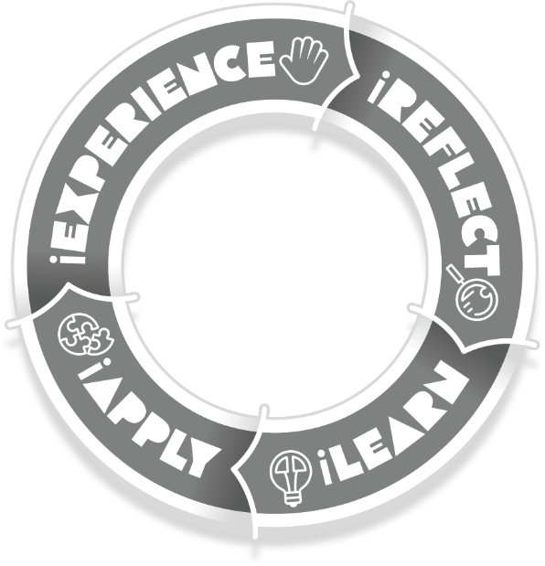
Pre-Arrival Preparation
Hello and welcome to the beginning of your term with the School for Student Leadership, we are all looking forward to meeting you!
Our program is based on experiential learning which, in a nutshell, means we try to learn from all experiences rather than just those that take place in the classroom. On the right is our experiential learning model, so we are keen to hear your reflections on some of the significant experiences in your life so far. Hopefully, we’ll both learn something about you through this process which we can apply in how we work with you and what we’ll work towards together.
To enable us to do this we’re asking you to complete the questions below. It starts with the general, introductory questions in grey, then progresses to the nine learning concepts which form the spine of our curriculum and the basis for your end-of-term assessment.
It is important while working through these questions that you remember the following:
- Read instructions (like this!) and questions carefully before responding.
- If you’re not sure what something means, ask! Ask a teacher, a friend, or your family; someone will help out.
- If you’re struggling to think of a response, ask the same people listed above, especially family and friends. They know you pretty well by now!
- Make sure you answer each part of the question fully. Some of the ‘questions’ in the learning concepts are made up of a number of smaller ones. Answer them all!
- Please send back to our campus: The Alpine School – Don Valley Campus alpine.sch.don.valley@education.vic.gov.au

Tell your story. Start at the start, answering all the following questions...
Who are you? Click or tap here to enter text.
Where were you born? Click or tap here to enter text.
Where do you live? Describe it. Click or tap here to enter text.
What do you like to do at school, at home, in your spare time? Click or tap here to enter text.
Who are your family? What do they do? Describe your relationship with them.
Do you have any family traditions? What are they? Are they important to you? Why?
Click or tap here to enter text.
Have you travelled much (either within Victoria, Australia or internationally)?
Where did you go? What did you see and do? Which is the most important to you and why?
Click or tap here to enter text.
Tell us about some things you’d like to happen for you in the future and explain your reasons. Click or tap here to enter text.
How did you come to be here at the School for Student Leadership?
Why did you want to be involved? Click or tap here to enter text.

Learning:
the gaining of knowledge or skills through study, experience, or being taught.
Strategy:
a plan of action designed to achieve a long-term or overall aim.
- Out of all the things you’ve learnt to do in your life so far, which was the most challenging and why? Explain what you did to learn it. How long did it take? What did you have to do to ‘get it’ in the end? How did it feel when you finally ‘got it’?
- Do you ask many questions, or ask for help? In what situations do you ask the most/least? Why is that? Be specific.
Answer all here!

Emotion:
a strong feeling coming from one's circumstances, mood, or relationships with others.
Management:
the process of dealing with or controlling things or people.
- What things make you, or have made you, truly happy, proud or contented and why?
- Think of a time you were really afraid, angry or sad. What happened and how did you react? What did you do next? Were you able to move past it? If so, how?
Answer all here!

Resilience:
the ability to recover quickly from difficulties; toughness.
- Think of a person in your life you see as resilient. Explain your choice and why you admire them.
- List your personal strengths, both physical and mental, and explain how you use them.
Answer all here!

Identity:
the fact of being who or what a person or thing is.
- Who has, or have, been the most influential person, or people in your life? How have they been so influential? What do they say and do? In what ways have they influenced you?
- Describe and explain a time in your life that changed you. What happened? How did it change you and what did you learn?
Answer all here!

Empathy:
the ability to understand and share the feelings of another.
- What is diversity? Does it exist within your school and local community? How? Is it important? Why?
- Is there someone in your life you feel you really understand; you ‘get’ them? Who is it? How did you come to understand them so well? What impact does this understanding have on your relationship?
Answer all here!

Respect:
a feeling of deep admiration for someone or something due to their abilities, qualities, or achievements, and care for the feelings, wishes, or rights of others.
Relationship:
the way in which two or more people or things are connected, or the state of being connected.
- What does a positive or respectful relationship look like? Do you have one that springs to mind? Explain your reasoning.
- What qualities do you value most in a friend and why? Do you have a friend like this? Who is it? How well do you display these qualities yourself?
Answer all here!

Collaboration:
the action of working with someone to produce something.
- Describe a time when you've worked well in a team environment, when you were a ‘good’ team member. How did you know you performed well? What did you do and say?
- How do you react to conflict or disagreements usually? Does it change depending on the people involved or the task? Give specific examples if you can. Would you like to change your reactions? If so, why? If not, why not?
Answer all here!

Health:
the state of being free from illness or injury.
Wellbeing:
the state of being comfortable, healthy, or happy.
- Describe some things that you do to manage your own health and well-being.
- Explain some ways that you look after the health and well-being of your friends and family.
Answer all here!

Environment:
the things that are happening, the objects, or conditions around you.
- Describe, draw or photograph your favourite environment, natural or otherwise. What do you enjoy most about being in this environment? Discover the indigenous name for the land your favourite environment sits on. Does the name have a meaning or story?
- There are many ways to be a part of and give back to your local communities, whether it be your family, your friends, sporting clubs, your school or local services like the CFA or SES. How involved are you in yours? What do you give back?
Answer all here!

Thanks for your reflections! We’re looking forward to reading them and meeting you.
Please send it back to our campus: The Alpine School – Don Valley Campus alpine.sch.don.valley@education.vic.gov.au, by the end of Term 3.
We also encourage you to bring photos to the school that relate to your responses if you can.
See you soon!

